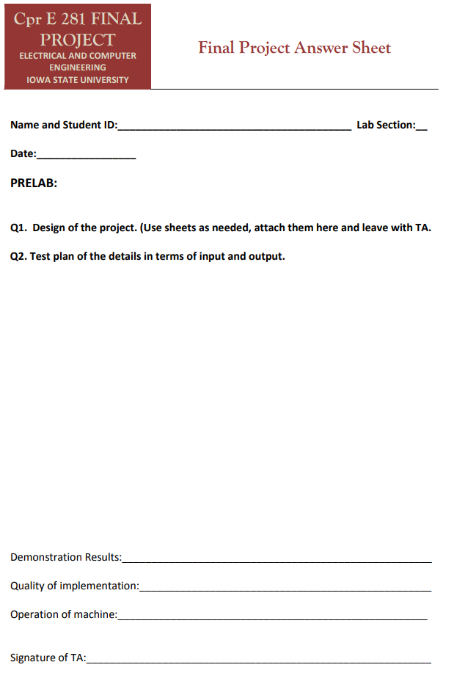

V

12/7/17

Logan Woolery 579483917

**LIST OF CUSTOM COMPONENTS**

Herein are the custom blocks made for this project. Each one was designed to integrate with the others, and be used more than once. The sketches of the development of these items is included at the end of the document.

**NOTE:** Items marked deprecated were not used in the final implementation, being replaced by more efficient designs.

* 8b_reg
  + An eight bit register with parallel load, parallel read, shift, and hold capabilities. Implemented with D-flip-flop’s and *mux*.
* Comparator
  + Checks two bits for equality, with enable. Uses NOR, AND, and OR.
* Compare
  + Replacement for comparator that accepts bus inputs
* Counter
  + Three bit asynchronous counter implemented with T flip flops.
* De_mux
  + 4-to-1 de-multiplexer. Takes two select lines.
* Decode_4_7s (deprecated)
  + Bit by bit converter for converting bus to 7seg inputs.
* EDC (deprecated)
  + EnterDisplayClear. Handles the storing and clearing of data values, using a *counter* and *8b_reg*.
* H_Lock
  + Keeps track of the number of incorrect attempts, and sends a disabling signal after 5.
* Mux
  + 1–to-4 multiplexer. Takes two select lines.
* Store
  + Replacement for *EDC* and *edit_store*. Handles multiplexing to multiple registers internally, adds bus support. This block handles the majority of the programs work.

**General Flow of Program**

*Push a button

*If not hard locked, pass to debouncer, then *store* block.

\**Store* checks if in edit or guess mode, then decodes the signal and writes to register

\**Store* tells program a key press has been accepted

+Button press counter increments

+If state 5 (4 presses and empty), sends a check&clear signal to check if the two registers hold the same values.

*If they match, open door, reset counters, empty the *guess* register

+If 5 checks without a successful unlock, disable input

+*Hide* block uses the output of the press counter to disable 7segs until they have been assigned a value this cycle.

*The signal to unlock or lock the door only lasts one clock cycle, so a TFF is used to hold that value. The TFF can be turned on only by the compare block, but can be turned off by either entering a new code, or pressing any key.

Store block

The store block handles the brunt of the work in this program. This block is implemented in Verilog. It takes input i1,i2,i3,i4,edit,clr,clk,reset; and outputs reg[7:0] key, reg[7:0] guess, and reg pressed. The module uses an iterator to move across the two registers, with the write location determined by a case statement, like the one for two:

if(i2 & ~reprog) begin

case(i)

0: guess[1:0] = 2'b01;

1: guess[3:2] = 2'b01;

2: guess[5:4] = 2'b01;

3: guess[7:6] = 2'b01;

endcase

i=i+1;

Note that the value and binary value is off-by-one.

enable =0;

end

Above this block, the code checks that there is only one button pressed, and that the last value passed is not the same as the current one. This prevents multiple inputs or filling the whole register in fractions of a second. Any time the code accepts an input, it outputs a 1 on pressed for one clock cycle. This tells the subsequent portions of the program to advance.

**Test Cases**

|  |  |  |  |  |
| --- | --- | --- | --- | --- |
| **COMMAND** | **7 SEG OUTPUT** | **HARDLOCK** | **LOCK** | **REPROG** |
| NULL | NULL | 0 | 1 | 0 |
| 1 | 1 | 0 | 1 | 0 |
| 2 | 12 | 0 | 1 | 0 |
| 3 | 123 | 0 | 1 | 0 |
| 4 | NULL | 0 | 1 | 0 |
| 4X15 | NULL | 1 | 1 | 0 |
| 1X* | NULL | 1 | 1 | 0 |
| HARD_RESET => 1 | NULL | 0 | 1 | 0 |

|  |  |  |  |  |
| --- | --- | --- | --- | --- |
| **COMMAND** | **7 SEG OUTPUT** | **HARDLOCK** | **LOCK** | **REPROG** |
| NULL | NULL | 0 | 1 | 0 |
| 1 | 1 | 0 | 1 | 0 |
| 1 | 11 | 0 | 1 | 0 |
| 1 | 111 | 0 | 1 | 0 |
| 1 | NULL | 0 | 0 | 0 |
| 4X4 | NULL | 0 | 1 | 0 |
| 1X4 | NULL | 0 | 1 | 0 |
| 4X4 | NULL | 0 | 0 | 0 |
| REPROG=>1 | NULL | 0 | 0 | 1 |
| 2X4 | NULL | 0 | 1 | 0 |
| 1X4 | NULL | 0 | 1 | 0 |
| 2X4 | NULL | 0 | 0 | 1 |
| REPROG=>0 | NULL | 0 | 0 | 0 |

|  |  |  |  |  |
| --- | --- | --- | --- | --- |
| **COMMAND** | **7 SEG OUTPUT** | **HARDLOCK** | **LOCK** | **REPROG** |
| NULL | NULL | 0 | 1 | 0 |
| 1 | 1 | 0 | 1 | 0 |
| 2 | 12 | 0 | 1 | 0 |
| CLR=>1 | NULL | 0 | 1 | 0 |
| CLR=>0 | NULL | 0 | 1 | 0 |
| 3 | 3 | 0 | 1 | 0 |

